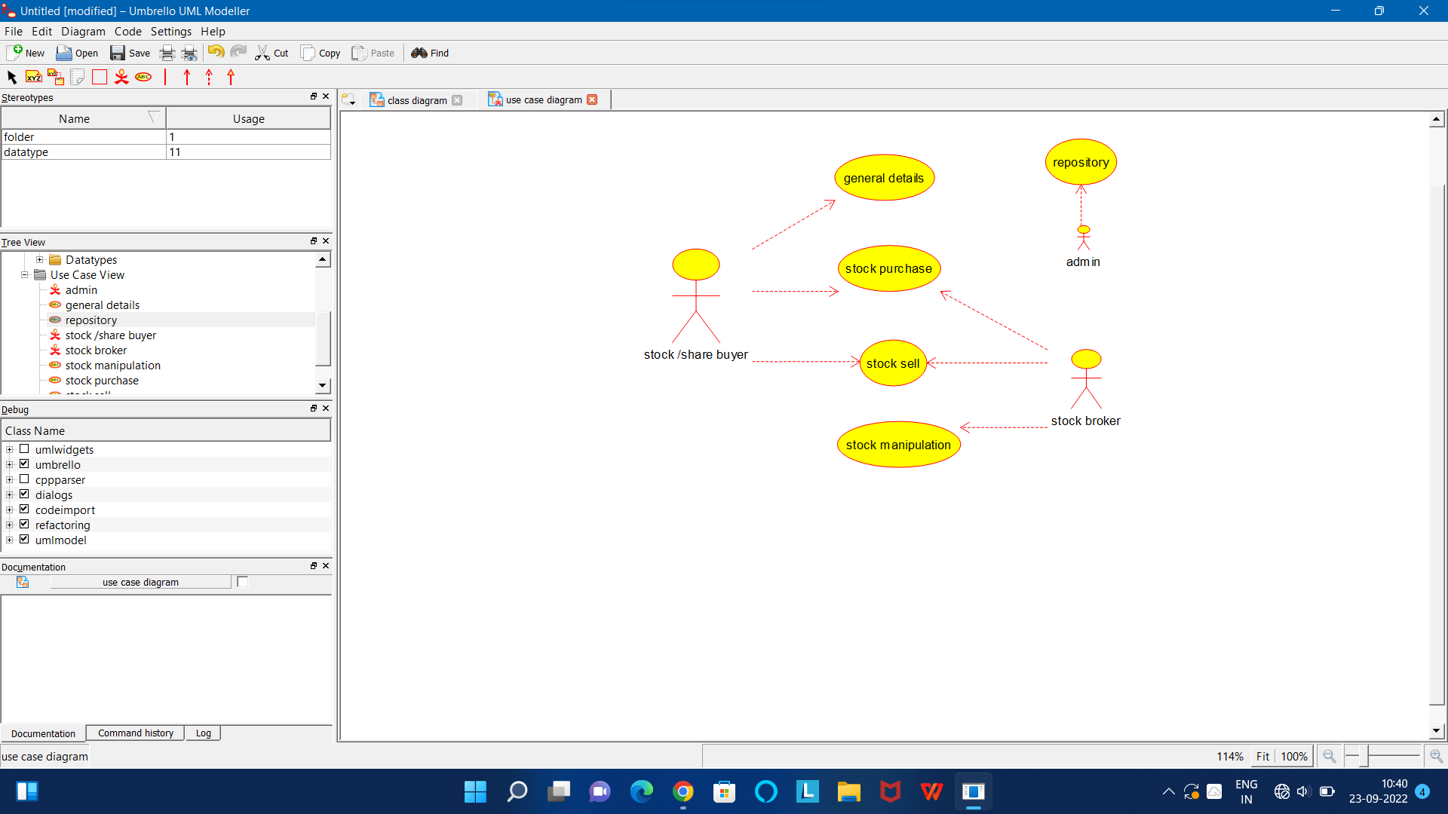

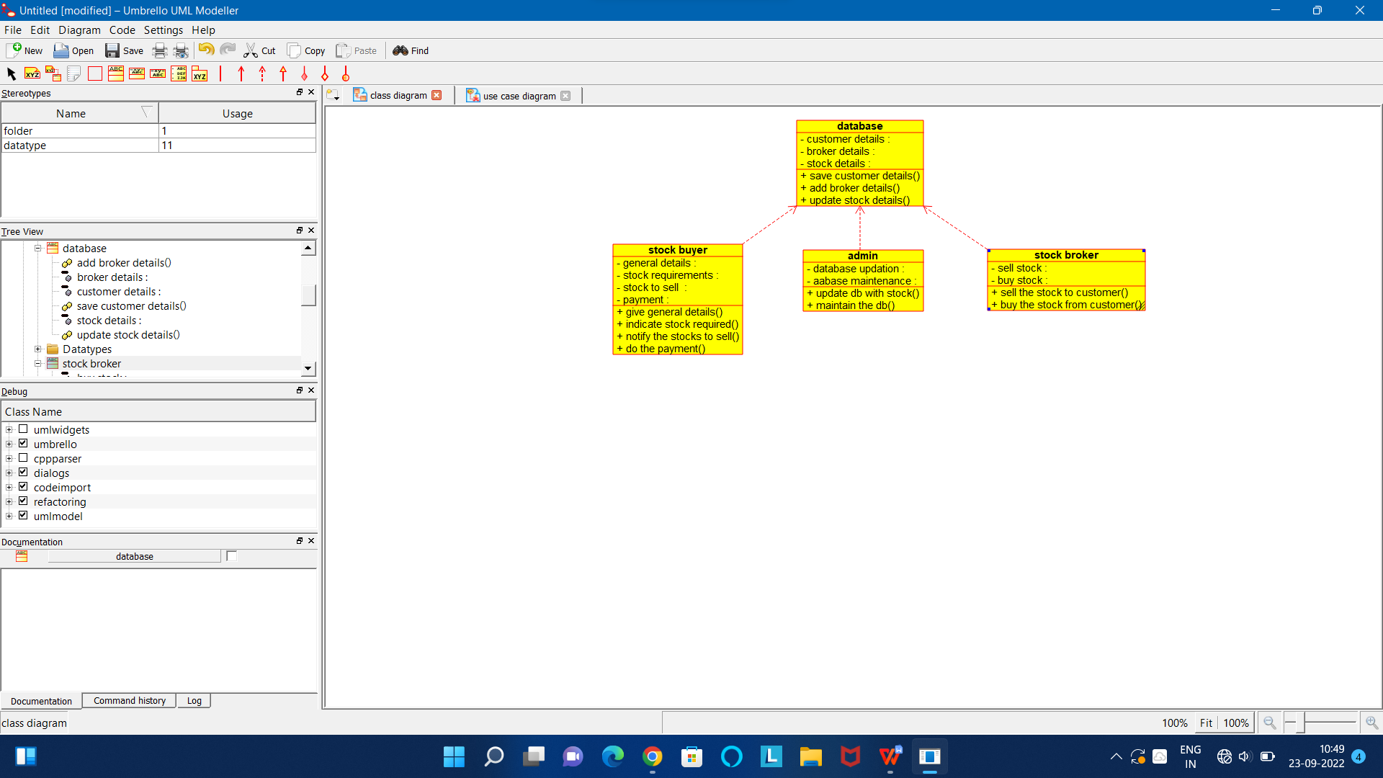

CODE FOR ADMIN:

/**

* Class admin

*/

public class admin {

//

// Fields

//

private void database_updation;

private void aabase_maintenance;

//

// Constructors

//

public admin () { };

//

// Methods

//

//

// Accessor methods

//

/**

* Set the value of database_updation

* @param newVar the new value of database_updation

*/

private void setDatabase_updation (void newVar) {

database_updation = newVar;

}

/**

* Get the value of database_updation

* @return the value of database_updation

*/

private void getDatabase_updation () {

return database_updation;

}

/**

* Set the value of aabase_maintenance

* @param newVar the new value of aabase_maintenance

*/

private void setAabase_maintenance (void newVar) {

aabase_maintenance = newVar;

}

/**

* Get the value of aabase_maintenance

* @return the value of aabase_maintenance

*/

private void getAabase_maintenance () {

return aabase_maintenance;

}

//

// Other methods

//

/**

*/

public void update_db_with_stock()

{

}

/**

*/

public void maintain_the_db()

{

}

}

CODE FOR DATABASE:

/**

* Class database

*/

public class database {

//

// Fields

//

private void insurer_detaills;

private void insurance_details;

private void validity;

private void payment_info;

//

// Constructors

//

public database () { };

//

// Methods

//

//

// Accessor methods

//

/**

* Set the value of insurer_detaills

* @param newVar the new value of insurer_detaills

*/

private void setInsurer_detaills (void newVar) {

insurer_detaills = newVar;

}

/**

* Get the value of insurer_detaills

* @return the value of insurer_detaills

*/

private void getInsurer_detaills () {

return insurer_detaills;

}

/**

* Set the value of insurance_details

* @param newVar the new value of insurance_details

*/

private void setInsurance_details (void newVar) {

insurance_details = newVar;

}

/**

* Get the value of insurance_details

* @return the value of insurance_details

*/

private void getInsurance_details () {

return insurance_details;

}

/**

* Set the value of validity

* @param newVar the new value of validity

*/

private void setValidity (void newVar) {

validity = newVar;

}

/**

* Get the value of validity

* @return the value of validity

*/

private void getValidity () {

return validity;

}

/**

* Set the value of payment_info

* @param newVar the new value of payment_info

*/

private void setPayment_info (void newVar) {

payment_info = newVar;

}

/**

* Get the value of payment_info

* @return the value of payment_info

*/

private void getPayment_info () {

return payment_info;

}

//

// Other methods

//

/**

*/

public void collect_insurer_details()

{

}

/**

*/

public void verify_insurance_details()

{

}

/**

*/

public void check_validity()

{

}

/**

*/

public void verify_payment()

{

}

}

CODE FOR STOCK BROKER:

/**

* Class stock_broker

*/

public class stock_broker {

//

// Fields

//

private void sell_stock;

private void buy_stock;

//

// Constructors

//

public stock_broker () { };

//

// Methods

//

//

// Accessor methods

//

/**

* Set the value of sell_stock

* @param newVar the new value of sell_stock

*/

private void setSell_stock (void newVar) {

sell_stock = newVar;

}

/**

* Get the value of sell_stock

* @return the value of sell_stock

*/

private void getSell_stock () {

return sell_stock;

}

/**

* Set the value of buy_stock

* @param newVar the new value of buy_stock

*/

private void setBuy_stock (void newVar) {

buy_stock = newVar;

}

/**

* Get the value of buy_stock

* @return the value of buy_stock

*/

private void getBuy_stock () {

return buy_stock;

}

//

// Other methods

//

/**

*/

public void sell_the_stock_to_customer()

{

}

/**

*/

public void buy_the_stock_from_customer()

{

}

}

CODE FOR STOCK BUYER:

/**

* Class stock_buyer

*/

public class stock_buyer {

//

// Fields

//

private void general_details;

private void stock_requirements;

private void stock_to_sell_;

private void payment;

//

// Constructors

//

public stock_buyer () { };

//

// Methods

//

//

// Accessor methods

//

/**

* Set the value of general_details

* @param newVar the new value of general_details

*/

private void setGeneral_details (void newVar) {

general_details = newVar;

}

/**

* Get the value of general_details

* @return the value of general_details

*/

private void getGeneral_details () {

return general_details;

}

/**

* Set the value of stock_requirements

* @param newVar the new value of stock_requirements

*/

private void setStock_requirements (void newVar) {

stock_requirements = newVar;

}

/**

* Get the value of stock_requirements

* @return the value of stock_requirements

*/

private void getStock_requirements () {

return stock_requirements;

}

/**

* Set the value of stock_to_sell_

* @param newVar the new value of stock_to_sell_

*/

private void setStock_to_sell_ (void newVar) {

stock_to_sell_ = newVar;

}

/**

* Get the value of stock_to_sell_

* @return the value of stock_to_sell_

*/

private void getStock_to_sell_ () {

return stock_to_sell_;

}

/**

* Set the value of payment

* @param newVar the new value of payment

*/

private void setPayment (void newVar) {

payment = newVar;

}

/**

* Get the value of payment

* @return the value of payment

*/

private void getPayment () {

return payment;

}

//

// Other methods

//

/**

*/

public void give_general_details()

{

}

/**

*/

public void indicate_stock_required()

{

}

/**

*/

public void notify_the_stocks_to_sell()

{

}

/**

*/

public void do_the_payment()

{

}

}